

**Nama Khoi Municipality**

**14 November 2024**

**MUNICIPAL FINANCE MANAGEMENT ACT (MFMA): MONTHLY REPORT FOR THE PERIOD ENDING 31 October 2024 (MONTHLY BUDGET STATEMENT) – 2024/2025 FINANCIAL YEAR.**

1. **PURPOSE**

71. (1) The accounting officer of a municipality must by no later than 10 working days after the end of each month submit to Mr R Kritzinger the Mayor of the municipality and the relevant Provincial treasury a statement in the prescribed format on the state of the municipality’s budget reflecting the financial affairs for that month and the financial year up to the end of that month:

1. **STRATEGIC OBJECTIVE**

The strategic objective of this report is to ensure good governance, financial viability, and optimal institutional transformation with the capacity to execute its mandate.

For the reporting period ended 31 October 2024

**3. QUERIES AND SUGGESTIONS**

**\*The financial services division will appreciate it if all queries and suggestions can be addressed to the Chief Financial Officer in writing.**

**Please note that the municipality wishes to notify the reader that information is subject to correction.**

1. **REPORT FOR THE PERIOD ENDING 31 October 2024**

**This report is based on financial information, as of 31 October 2024, and is available during preparation.**

The financial results for the period ended 31 October 2024 are summarised as follows:

Statement of Financial Performance (SFP) **(Annexure B – TABLE C4**

**Table of Contents**

|  |  |  |  |  |  |  |  |  |  |
| --- | --- | --- | --- | --- | --- | --- | --- | --- | --- |
| Page 3 |  |  |  | Table C4-Financial Performance |  |  |  |  |  |
| Page 4 |  |  |  | CHART 1- Revenue by source |  |  |  |  |  |
| Page 5 |  |  |  | CHART 2 – Expenditure by type |  |  |  |  |  |
| Page 6 |  |  |  | Table C3 – Revenue and Expenditure by Vote |  |  |  |  |  |
| Page 8 |  |  |  | CHART 3 – Revenue by Vote & Variances |  |  |  |  |  |
| Page 8 |  |  |  | CHART 4 – Expenditure by Vote & Variances |  |  |  |  |  |
| Page 9 |  |  |  | Capital Expenditure |  |  |  |  |  |
| Page 10 |  |  |  | Cash Flow Statement |  |  |  |  |  |
| Page 11 |  |  |  | Debtors Age Analysis |  |  |  |  |  |
| Page 16 |  |  |  | Creditors age analysis |  |  |  |  |  |
| Page 16 |  |  |  | Employee Related Cost |  |  |  |  |  |
| Page 17 |  |  |  | Other Required Financial Information as per Treasury Guidelines |  |  |  |  |  |
| Page 21 |  |  |  | Financial Implications/Recommendations |  |  |  |  |  |
| Page 22 |  |  |  | Interdepartmental and Cluster Impact |  |  |  |  |  |
| Page 24 |  |  |  | Quality Certificate |  |  |  |  |  |
| Page 24 |  |  |  | Annexure A |  |  |  |  |  |
| Page 26 |  |  |  | C-Schedule Table of contents |  |  |  |  |  |





**Explanation on YTD variance % - e.g. 104% means that the municipality billed 4% more than what was budgeted and 98% means the municipality billed 2% less than what was budgeted.**

Variances to be discussed in the Institutional and Finance Committee

**Matters of Concern**

Revenue billed should not be seen as actual cash received, The Statement of Financial Performance sometimes gives the reader the idea that the municipality already collected the billed revenue; additionally, it should not be confused with the collection rate as variances relate to the expected budgeted versus the actual billing.

The underperformance of Service Charges is of concern, especially refuse removal and sanitation where the municipality does not have initiatives to limit the over-time incurred to deliver these services.

It must be noted that property rates will be adjusted downwards after the Council approves a further rebate/downward adjustment of the tariff.

The system allows only for the projected budgeted figures to be divided equally this results in unfavorable variances on a month-to-month basis.

The electricity billing results from the municipality failing to bill a portion of the previous months when the summer tariffs were introduced.

It must be noted that the municipality is in the process of taking over the Town of Kleinzee and the revenue will increase, the necessary adjustments towards revenue must be done with the Adjustment Budget.

**CHART 1**

**The following chart shows the revenue by source for the month of 31 October 2024 in terms of revenue as a percentage of total revenue.**

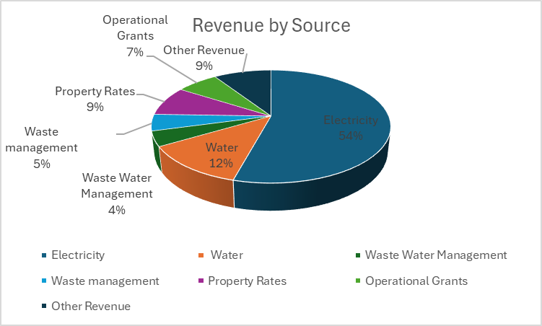



**Notes on variances above/under 10%**

Variances to be discussed in the Institutional and Finance Committee

**Matter of Concern**

**Debt impairment and Depreciation: T**he municipality's asset register is not linked to the financial systems, and journals are only passed at year-end.

Low expenditure is due to the cash flow situation of the municipality, the low spending has a direct impact on service delivery initiatives.

Contract services are linked to consultants the municipality uses for various services, including performance management, accounting assistance towards the AFS, asset register, and other service delivery items.

Bulk electricity includes invoices from the previous month.

**CHART 2**

**The following chart shows the expenditure by type in terms of expenditure at a percentage of total expenditure, Chart as per the information above**

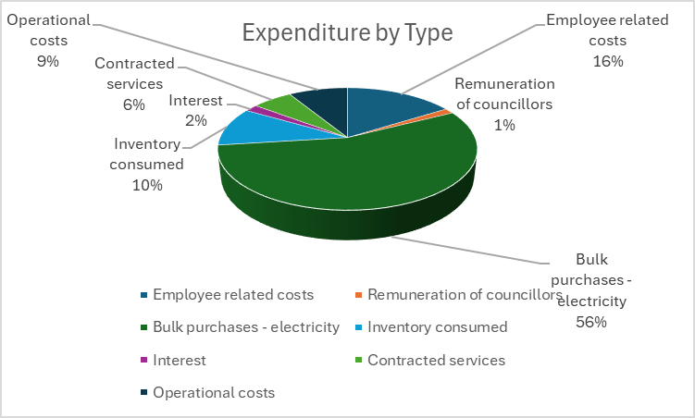

**The table below indicates revenue and expenditure by vote.**

**Annexure B – Table C3**



**Reasons for variances above/under 10%**

Variances to be discussed in the Institutional and Finance Committee

**CHART 3**

**The following chart shows the revenue by vote for 31 October 2024**



**Notes on Table Above**

Revenue billed does not necessarily mean the monies have collected the actual cash

It must be noted Revenue by function includes capital revenue recognized resulting in the difference when compared to revenue by source.

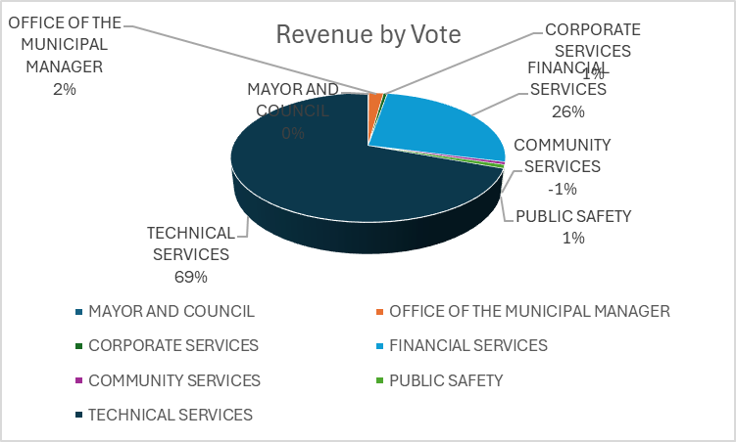

**CHART 4**



**The following chart shows the expenditure by vote for 31 October 2024**

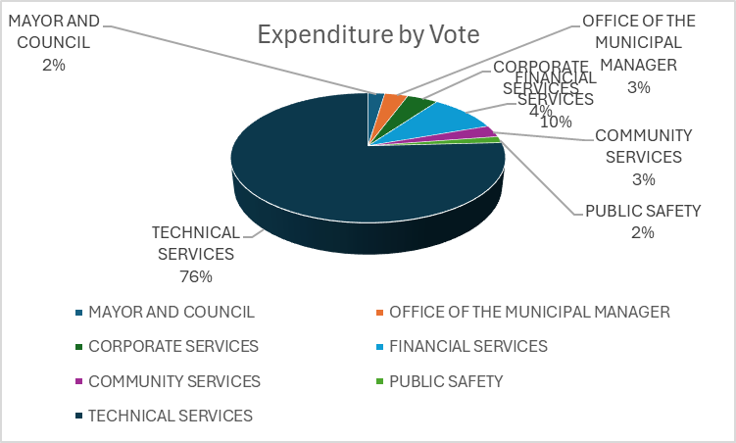

**Reasons for variances above/under 10%**

Variances to be discussed in the Institutional and Finance Committee

**The Capital expenditure report shown in Annexure B has been prepared based on the format required by the National Treasury.**

**Please note Capital Expenditure is subject to correction. Errors have been submitted to the Service Provider**



**CASH FLOW STATEMENT ON 31 October 2024**



**Notes on the Cash Flow Statement**

Please note that opening and closing balances are subject to correction and include conditional grants.

Please see the letter from the Service Provider on the errors on the Balance Sheet and the Cash Flow Statement

It must also be noted that the cash/cash equivalents balance includes unspent grants.

It must be noted that the R121 million does not reflect the correct corresponding bank status with the call accounts included, as there are some errors in the financial systems. Bank reconciliation and grant reports will reflect the correct status.

**Debtors Age Analysis - Annexure B -Table SC3**

**The debtor’s age analysis report shown in Annexure B has been prepared based on the format required by the National Treasury. The following report shows the debtor’s outstanding on 31 October 2024.**

**Debtors are subject to correction, the municipality experienced challenges while converting to the new system.**



The debtor’s outstanding for more than 121 days amounts to R372 158 413

The municipality through the TID rollover process has started to replace faulty and by-passed meters, the results of these actions can be found in the monthly progress reports. Additionally, the municipality has started to write off debt for customers if they are prepared to take prepaid meters to control the municipal outstanding accounts and collect monies before the service is delivered.

It’s clear that a certain portion of billed revenue results in debtors, this can be a result of long outstanding disputes that have accumulated interest, and the interest is accumulated interest on interest every month, the municipality is in the process of considering the write-off of these outstanding debts.

**Chart 8 – Debtors per revenue source**



**The following chart shows the debtors outstanding per revenue source, Chart as per the information above**

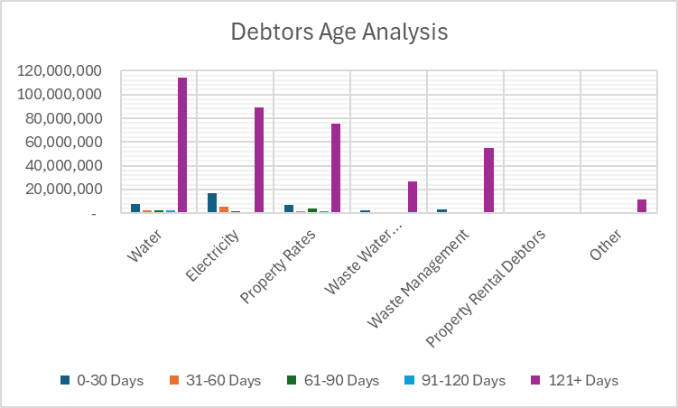

**Debtor Age Analysis by Category**



**CHART 9**

**The following chart shows the outstanding debtors per category, as per the information above.**

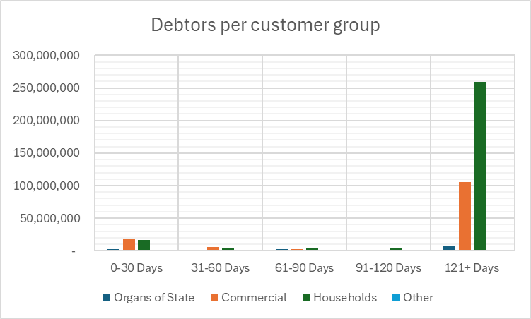

**Revenue Enhancement Initiatives/Progress**

**New Meters Installed – Information for the month of October to be added once verified**



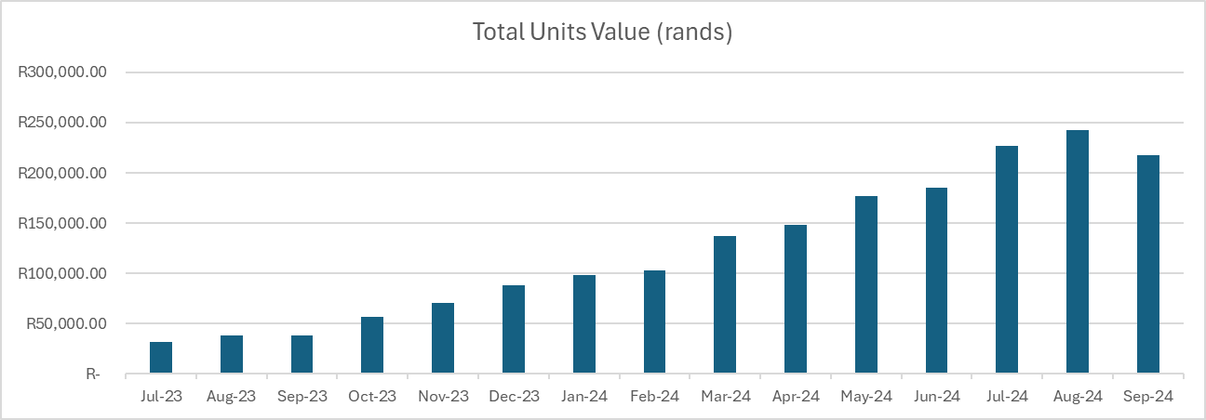

**Old Replacement - Meters Information for the month of October to be added once verified**



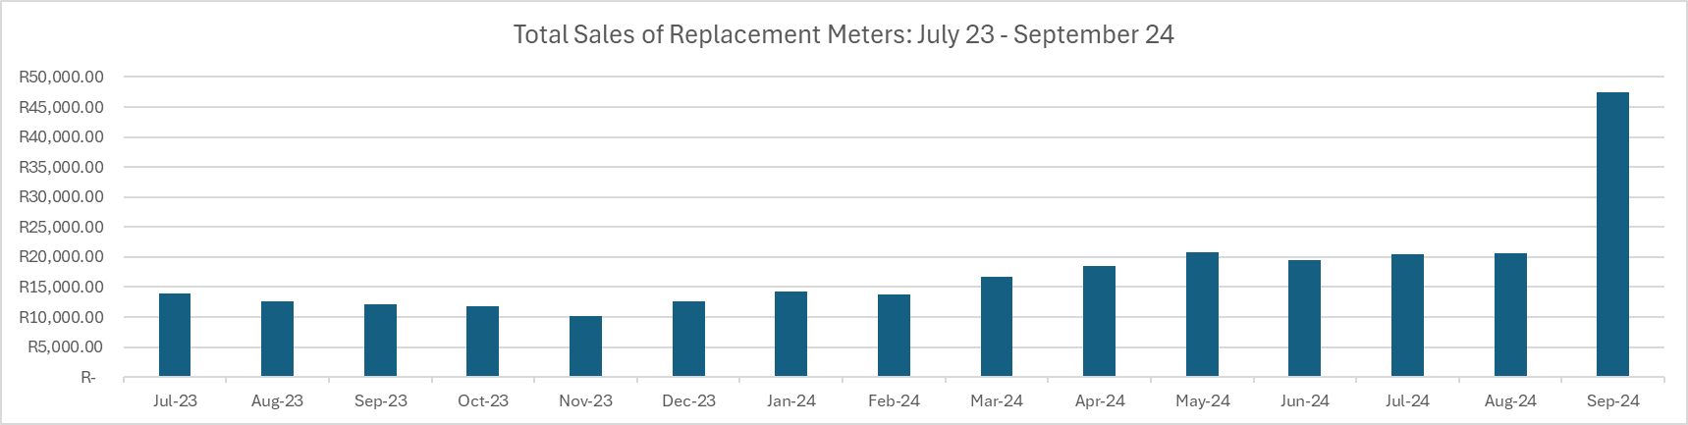

**Notes on the Above tables**

The tables above show the impact the municipality made by installing and replacing faulty electricity meters, progress has been hampered by finances available to purchase prepaid meters, as well as the capacity issues at the municipality, and lastly the availability of a cherry picker to replace meters outside the houses of consumers.

**TID Rollover Status**

**TID Rollover Summary**

Overall, 5194 active STS meters were successfully TID Rolled-over during field inspections, while 2486 meters were set up on the system for conversion during phase 2-customer approach with 1203 meters purchasing electricity after being set up for TID and 1283 meters have not yet purchased to confirm the success of TID on the physical meter.

**TID completed during Field Approach**

5194

**Meters Issued with TID via customer Approach**

2486

**Meters with purchases after TID**

1212

**Meters without purchases after TID**

1200

Please note that although 2486 meters were issued with TID, only a total 2412 meters(meters with sales + meters with no sales) is indicated in this report due to possbile meter changes( replacements OR disconnections) of the 74 meters from the original 2486 meter list.

**Next Steps**

The Syntell Team continues to monitor the 1200 meters which have not yet purchased after the TID tokens were distributed and progress is communicated weekly to the municipality for visibility.

Nama Khoi should consider cleaning the database by removing meters that do no have last purchase date or purchase datesolder that two years.

**CREDITORS Age Analysis - Annexure B -Table SC4**

**The creditor’s age analysis report shown in Annexure B has been prepared based on the format required by the National Treasury.**

**The following report shows the creditor’s outstanding on 31 October 2024.**



**Creditors Analysis**

Please note creditors’ report is subject to correction

From the creditors’ age analysis, the municipality has two main creditors: ESKOM and Vaal Central Water.

The municipality applied for the Debt Relief Program and was successful in the application, furthermore, payments thus have been made in consultation with ESKOM.

The municipality has payment agreements with other creditors.

The municipality has a National Dispute with Sedibeng Water now Central Vaal Water



***Employee-related cost to total expenditure*** – Please note employee cost against expenditure amounts to 16%

It must be noted that the Performance Bonus for other municipal staff relates to the 13th cheque/birthday bonus.















**Financial Implications /Recommendations**

**Revenue by Type:**

The municipality must apply section 64 of the MFMA to adhere to all the revenue requirements, additionally, the following must be introduced or must be improved on:

Credit control and debt collection using pre-paid water meters not only in Eskom areas but also defaulters all over the municipal jurisdiction.

Distribution of correct consumer accounts and also the timely correction of errors should they occur.

Updated and verified indigent register.

Replacement of faulty meters needs to be fast-tracked.

Implementation of green energy initiatives should be carefully monitored to ensure the municipality does not make a loss.

**Expenditure by type:**

The municipality must apply section 65 of the MFMA to adhere to all the expenditure requirements, additionally, the following must be introduced or must be improved on:

Cost containment measures and controls must be adhered to.

Repairs and maintenance must be done in a manner that ensures the same asset does not keep being repaired.

Should get a balance between technology and manual labour.

Must ensure that bulk accounts are verified and correct.

Get a balance on the overtime and standby hours.

**Capital Expenditure:**

The municipality must apply section 19 of the MFMA to adhere to all the expenditure requirements, additionally the following must be introduced or must be improve on:

Must ensure that Procurement Plans aligns to the IDP, Budget and SDBIP.

Business plans are submitted on time

SCM processes start before the start of the financial year

Implementation plans are carefully monitored

**Cash Flow Statement:**

Expenditure should be linked to the cash flow budget, once cash is less than budget corrections must be done to avoid the municipality running into cash flow problems. The municipality should strive to use the cash received wisely and for the intended purpose as planned. The municipality should strive to spend less cash than it has received to avoid going into a negative cash balance. Revenue/Cash recovery must be structured so that the old outstanding funds received will be used to either settle outstanding creditors or fund projects that can enhance revenue recovery.

**Debtors Analysis**

The municipality needs to ensure better distribution of information to the community as well as Councillors. The distribution of monthly accounts should be 100% correct and all methods of distributing accounts should be explored with the best methods being introduced for the different wards. The municipality must also establish a better workflow between departments to ensure the community won’t end up with unnecessary accounts.

**Creditors Analysis**

The municipality must adhere to paying monthly creditors on time, and old outstanding debt must be prioritized and linked to the Funded Budget Plan. Intervention is needed regarding the outstanding debt of bulk services. The municipality should strive to receive accounts that can be serviced every month; therefore, communication between all relevant parties is vital. The municipality needs to finalize the action plans against the two biggest creditors.

**General Note**

Central Vaal Water has not been paid as required.

Strict adherence to Credit Control Measures is required.

The municipality has upgraded to Promun 3 and some challenges have been experienced more specifically in the income department, the municipality did have problems with the distribution of accounts with consumers complaining that their accounts were incorrect.

Some challenges are also being experienced during the audit with some reports that differ from the reports in Promun 2.

The takeover of Kleinzee town was not budgeted and will cause unauthorized expenditure in certain expenditure items, especially in the salaries and the bulk purchases.

It is important that the Council take note of the differences in tariff between Nama Khoi Municipality and De Beers tariff structures, and also take note of the income received for the services in Kleinzee versus the expenditure incurred.

**Circular 124 Debt Relief**

Monthly monitoring tool to be submitted.

Must be noted that the municipality has not managed to make full payment to Vaal Central Water.

The municipality did design an app that aligns with the debt relief monitoring report.

**Funded Budget Plan and Cost Containment Report**

Progress on the Funded Budget completed as required, report will be submitted as required. It must be noted that updates from other departments are not submitted.

The National Treasury has re-assess the budget and has found it to be unfunded

The municipality has several votes that are overspent and were required to open the parameters that block transactions once a vote has reached the budgeted amount, the finances are keeping track of these transactions and will table them at the Mid-Year Assessment.

**6. Interdepartmental and cluster impact**

This report is prepared to achieve MFMA compliance.

**7. Comments of the Head: Legal Services**

The above-mentioned report as such does not call for legal clarification.

**8. Conclusion**

This report was compiled in accordance compliance with section 71 of the MFMA, by providing a statement to the Council containing certain financial particulars.

**Prepared By:**

Heinri Cloete

Chief Financial Officer

**NAMAKHOI MUNICIPALITY QUALITY CERTIFICATE**

I, …………………………………., the Municipal Manager of Nama Khoi Municipality, hereby certify that –

* The monthly report on the implementation of the municipal budget and financial state affairs for the month ending 31 October 2024 has been prepared by the Municipal Finance Management Act 71 and regulations made under that Act.

**Print Name: J I Swartz**

Municipal Manager of Nama Khoi Municipality

Signature:…………………………………………………………….

Date: ………………………………………………

**Annexure A**

**Reports and reportable matters**

**Monthly reports statements – Section 71 MFMA**

(1) The accounting officer of a municipality must no later than 10 working days after the end of each month submit to the relevant provincial treasury a statement in the prescribed format on the state of the municipality’s budget reflecting the following particulars for that month and the financial year up to the end of that month:

(a) Actual revenue, per revenue source

(b) Actual borrowings

(c) Actual expenditure per vote

(d) Actual capital expenditure per vote

(e) The amount of any allocations received

(f) Actual expenditure on those allocations, excluding expenditure on –

(i) Its share of the local government equitable share, and

(ii) Allocations exempted by the annual Division of Revenue Act from compliance with this paragraph; and

(g) When necessary, an explanation of –

(i) Any material variances from the municipality projected revenue by source, and from the municipality’s expenditure projections per vote;

(ii) Any material variances from the service delivery and budget implementation plan; and

(iii) Any remedial or corrective steps taken or to be taken to ensure that projected revenue and expenditure remain within the municipality’s approved budget

(2) The statement must include –

(a) A projection of the relevant municipality’s revenue and expenditure for the rest of the financial year, and any revisions from initial projections; and

(b) The prescribed information relating to the state of the budget of each municipal entity the municipality in terms of section 87 (10)

(3) The amounts reflected in the statement must in each case be compared with corresponding amounts budgeted for in the municipality’s approved budget

(4) The statement to the provincial treasury must be in the format of a signed document and the electronic format.

(5) The accounting officer of a municipality that has received an allocation referred to in subsection (1) (e) during any particular month must by no later than 10 working days after the end of that month, submit that part of the statement reflecting the particulars referred to in subsection (1) (e) and (f) to the national or provincial organ of state or municipality which transferred the allocation.

(6) The provincial treasury must by no later than 22 working days after the end of each month submit to the National Treasury a consolidated statement in the prescribed format on the state of the municipalities’ budgets per municipality and municipal entity

(7) The provincial treasury must, within 31days after the end of each quarter, make public as prescribed, a consolidated statement in the prescribed format on the state of municipalities’ budget per municipality and municipal entity. The MEC for finance must submit such consolidated statements to the provincial legislature no later than 45 days after the end of each quarter.

